**Upgrade and DownGrade PHP Multiple Version**

Create EC2 Server and Connect with Localmachine

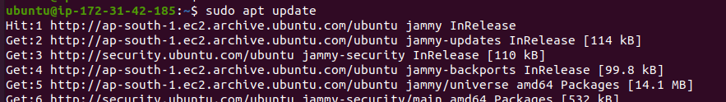

sudo apt update

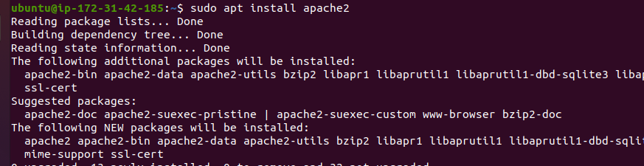

sudo apt install apache2 -y

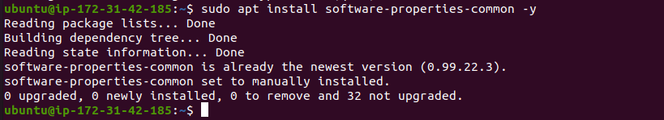

sudo apt install software-properties-common -y

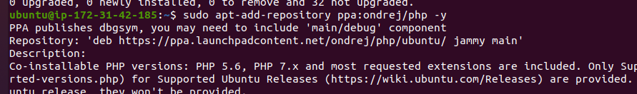

sudo apt-add-repository ppa:ondrej/php -y



sudo apt install -y php7.4

<?php

phpinfo();

?>

sudo systemctl restart apache2.service

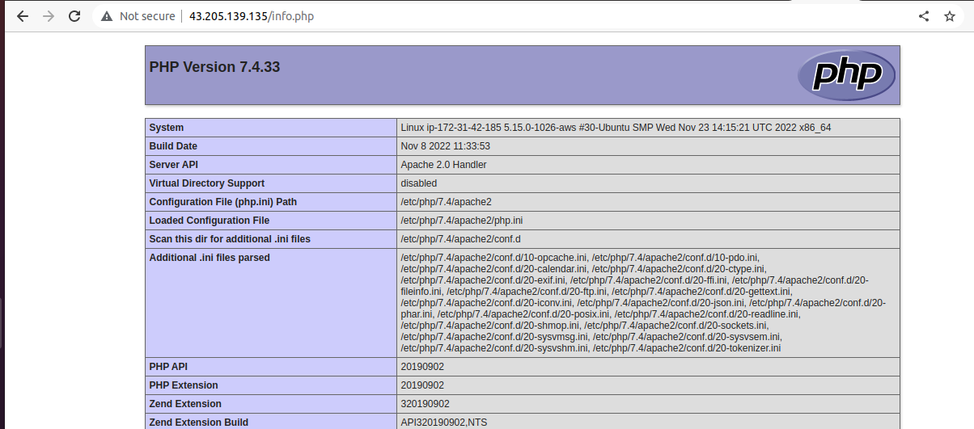

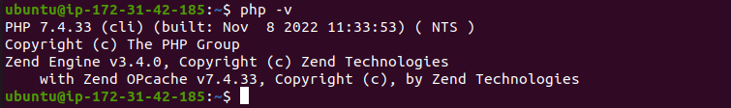

install php8.1

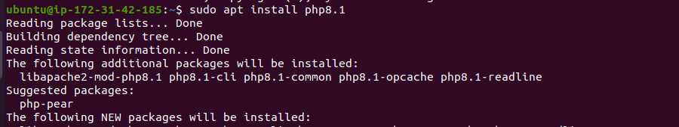

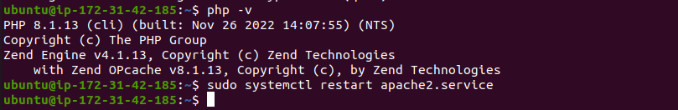

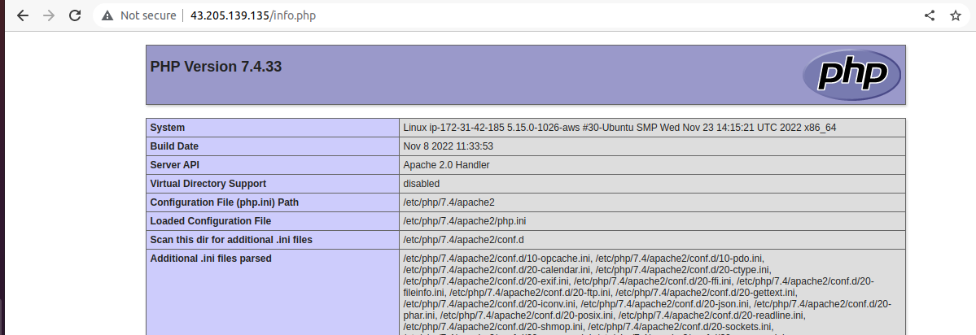

sudo update-alternatives --config php

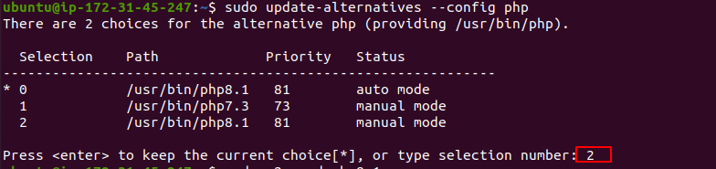

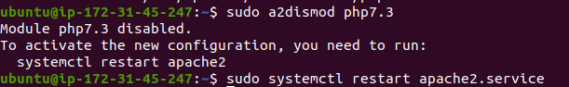 sudo a2dismod php7.3

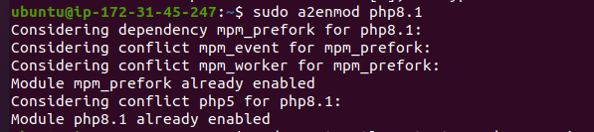sudo a2enmod php8.1

